**AWS RDS - Postgress**

* Login to AWS console and go to RDS Service
* Choose “**Create database**”
* At next page choose the following in the “Engine Section”:

“Standard Create”

“PostgreSQL”

“SQL Version”

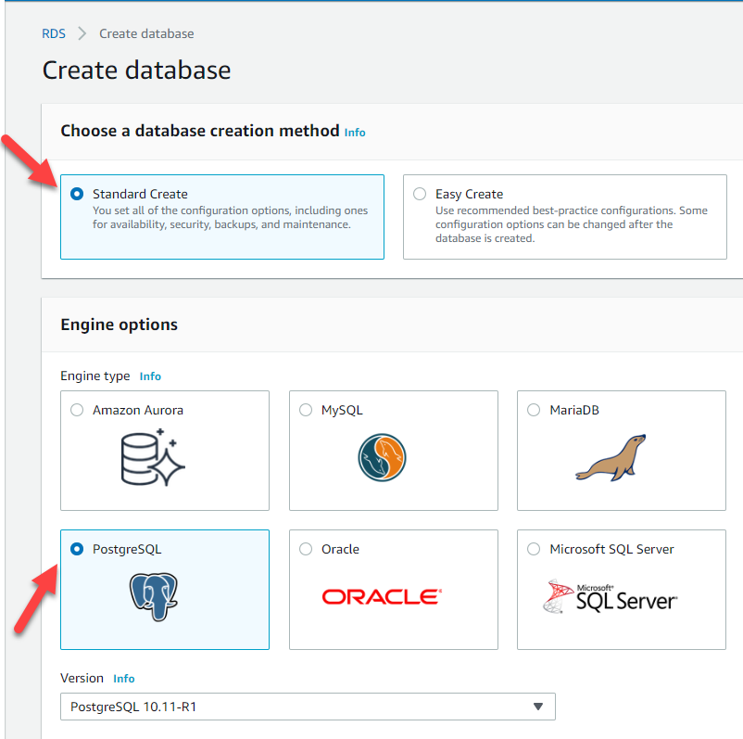

* In the template section choose **production** for support in Multi zone and better performance
* In the Settings section configure the following:

1. DB instance Identifier - ????
2. Master username: should be postgres
3. Password -????

* In the instance size section choose the right DB size needed according to requirements.
* In the Storage section choose the values according requirement (allocated storage and Maximum Storage threshold, the rest leave the default unless requested otherwise)

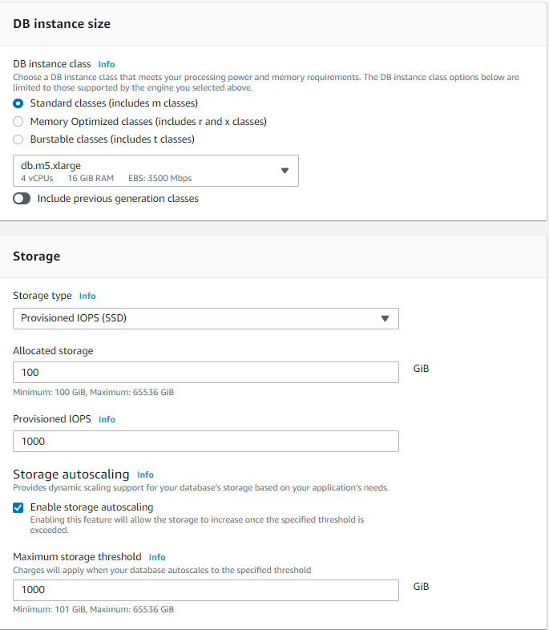

* In the Availability and durability choose if **multi zone** or not (in most cases multi zone is better from performance and future support for features)
* In the Connectivity section choose the right networking to which deploy the RDS.
* In the authentication section choose “Password authentication”

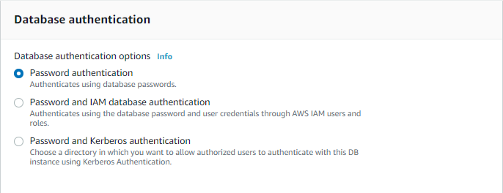

* In the additional section:

1. Enable automatic backups (Configure backups and retention according to requirements)
2. Enable encryption with “(default) aws/rds” key
3. Enable Performance Insights
4. Enable Enhanced monitoring
5. Enable auto minor version upgrade
6. Enable deletion protection

* After all fields are configured choose “Create”
* Once database is up sent to GS/DBA the full endpoint string and user/password